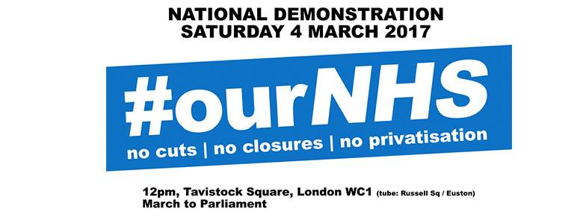
Our NHS is at breaking point. Dismissed by the government as “winter pressure”, what the British Red Cross have dubbed a “humanitarian crisis” has been a long time coming. On the backdrop of continued cuts and closures, private companies seek to gain even more of a foothold within the NHS.
Continued pay restraint has seen the value of NHS staff salaries reduce by 14% since 2010 and there are now 25,000 nursing and 3500 midwifery vacancies in NHS England alone.
Theresa May's demands for yet more austerity in the NHS represent a real risk to the safety of patients and the service. The government's latest Sustainability and Transformation Plans risk being used as a smokescreen for further cuts and privatisation.
The NHS is the single greatest achievement of the trades union and labour movement. We cannot allow it to be undermined and ultimately destroyed. We must march together, sending a clear message to the government; "the NHS will last as long as there are folk with the faith to fight for it".
This body resolves to fully support the national demonstration "It's Our NHS" on 4th March called by Health Campaigns Together with The People’s Assembly and calls on all other parts of the union to do the same.
We resolve to help build for the demonstration engaging in a range of actions such as:
- Communicating our support to all members and encouraging them to attend.
- Promoting the demonstration through leafletting and postering activities.
- Working appropriate local campaign organisations to hold a public meeting on the NHS in the run up to the demonstration.
- Working with appropriate local campaign organisations to co-ordinate transport to Tavistock Square

